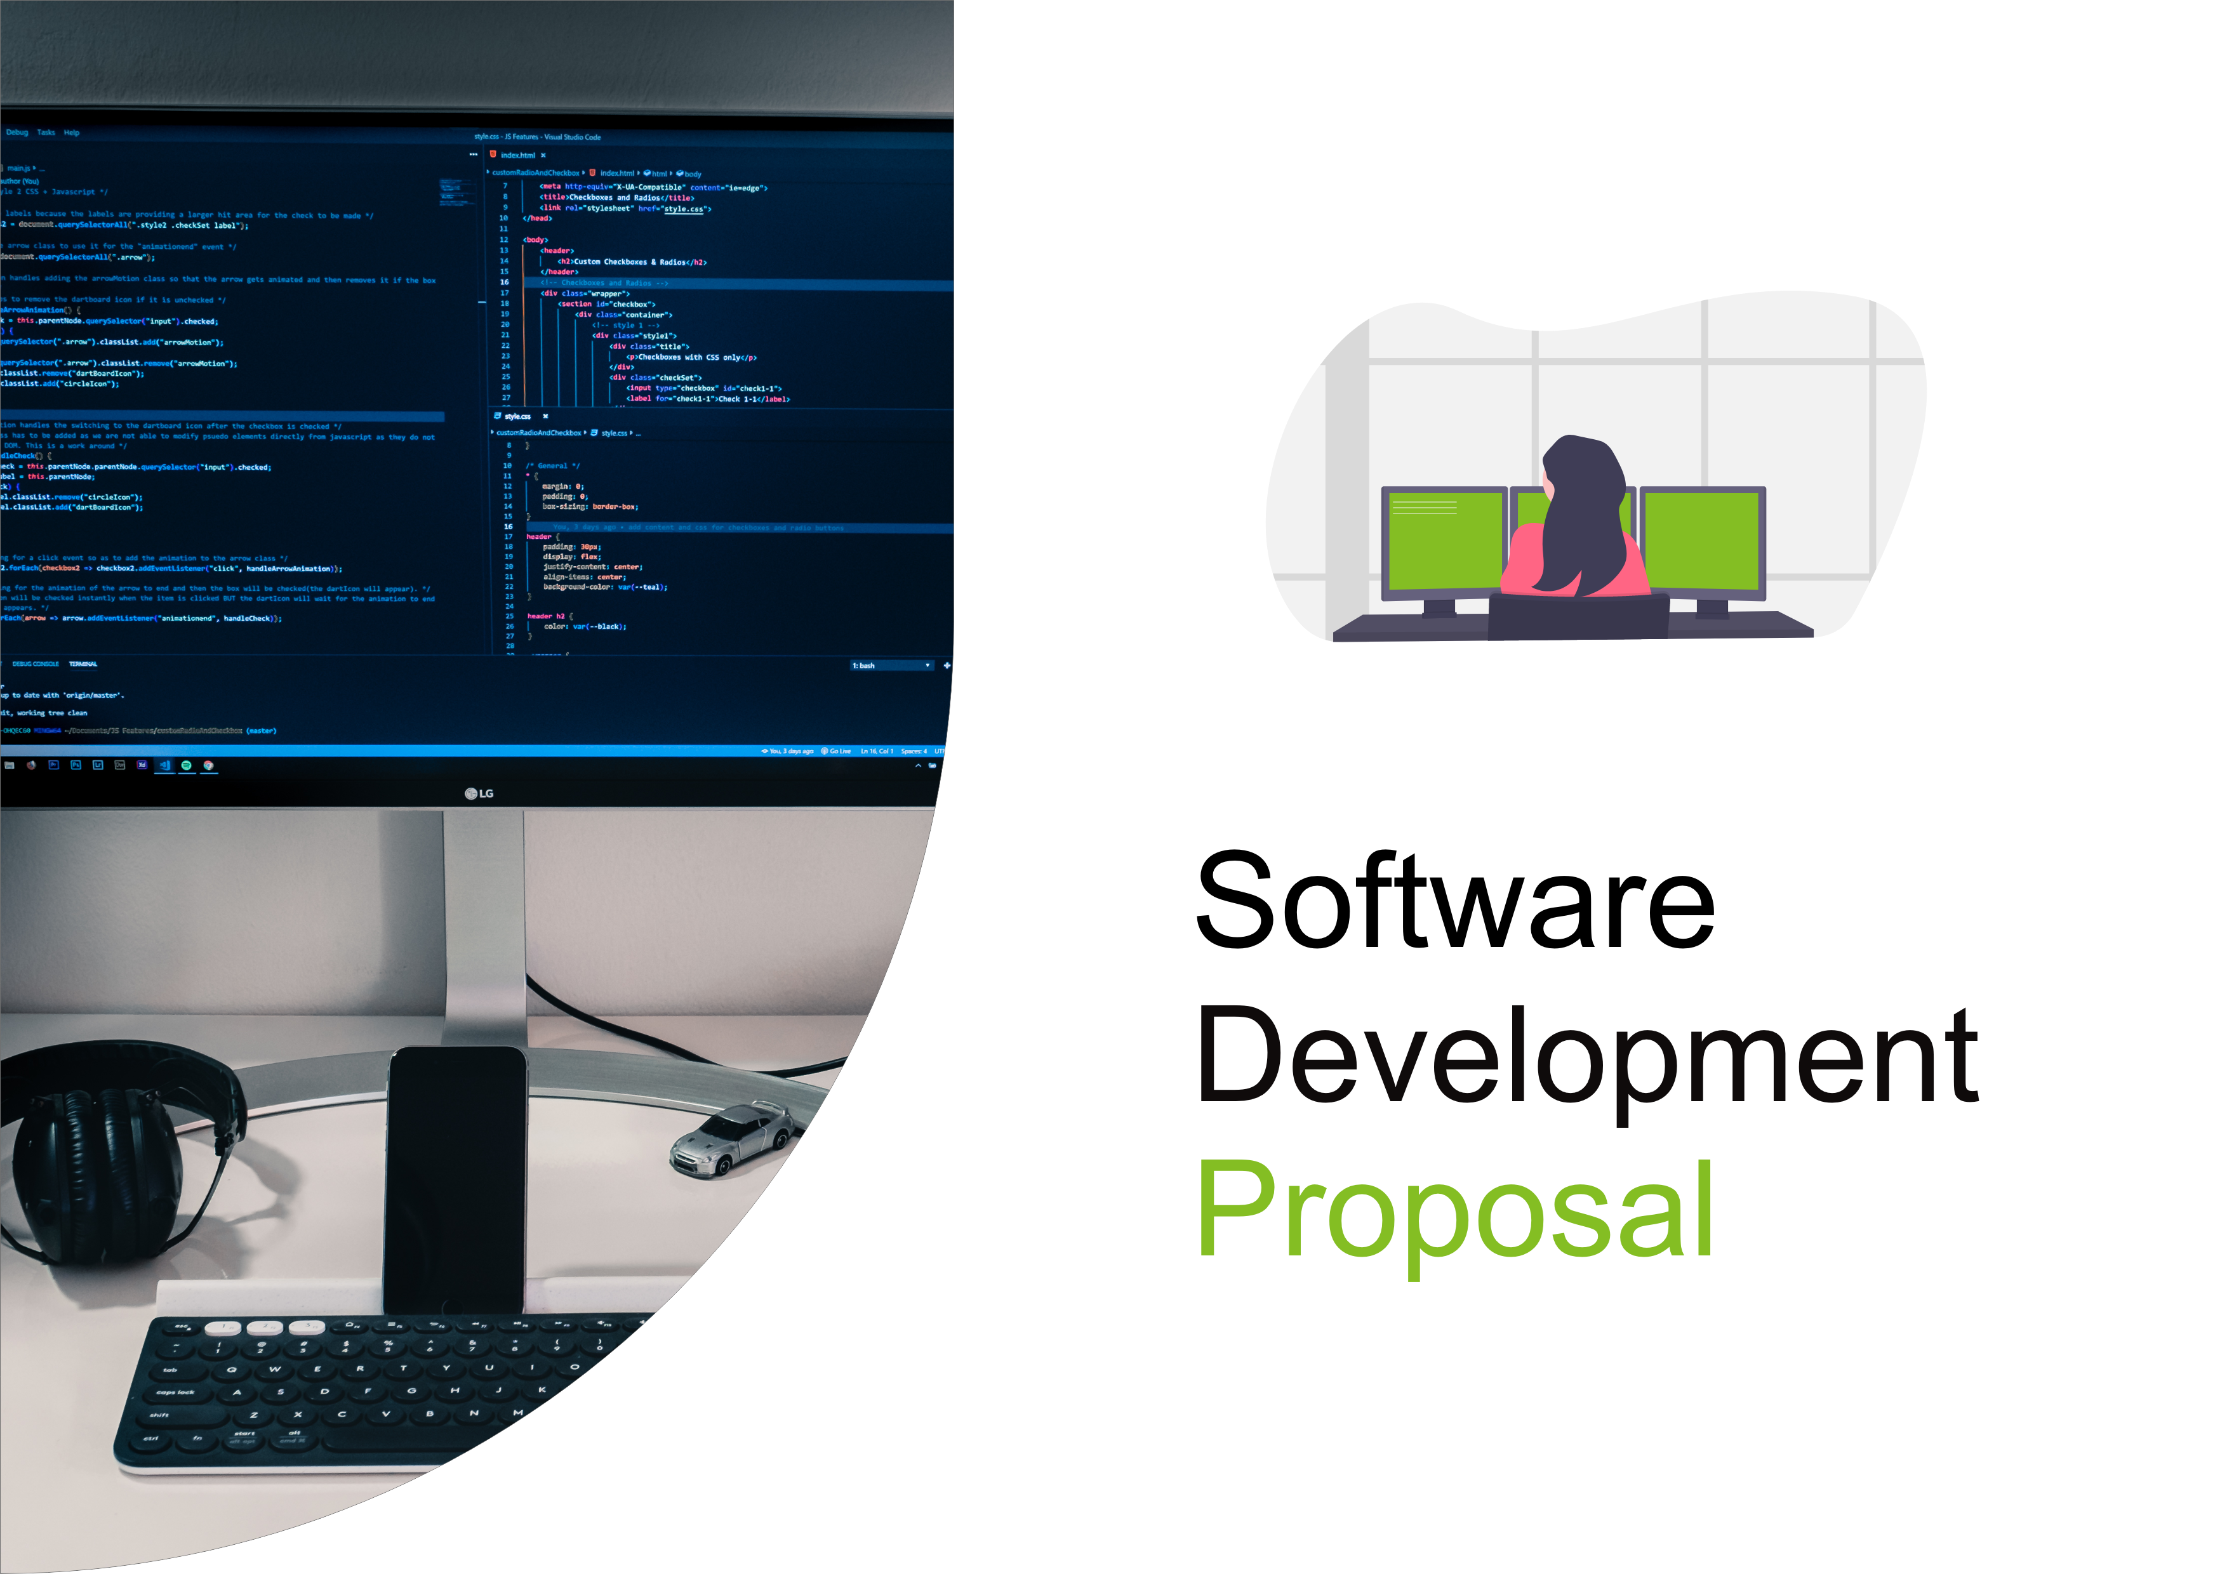
1. Overview

Deloitte proposes the development of a secure, real-time manufacturing status dashboard for Daikibo Industrials. The dashboard will provide authorized employees with a centralized view of the operational health of all monitored machines across the company's four manufacturing facilities. The system will display the current status of each machine, allow users to review historical status information, and support real-time monitoring of manufacturing operations.
The application will be accessible only through Daikibo's internal intranet and will integrate with the company's existing authentication system, allowing employees to securely log in using their company accounts. The proposed solution aims to improve operational visibility, reduce response times to equipment issues, and support informed decision-making through an easy-to-use monitoring interface.

2. Scope

The proposed dashboard will provide a single-page interface for monitoring the operational health of all manufacturing equipment across Daikibo's four factories. The dashboard will include the following functionality:
- Secure access through Daikibo's internal intranet.
- User authentication integrated with the company's existing authentication server.
- Display the real-time health status of all nine monitored machines within each of the four factories.
- Present factory information in a collapsible and expandable hierarchy.
- Allow users to expand each factory to view its machines.
- Allow users to expand each machine to view its recent status history.
- Display machine status indicators such as Healthy and Unhealthy.
- Show the timestamp of the latest status update for each machine.
- Automatically refresh the displayed information as new telemetry data becomes available.
The dashboard layout will follow the wireframe provided in the proposal template, with expandable factory and machine sections designed to provide a clear and organized view of manufacturing operations.

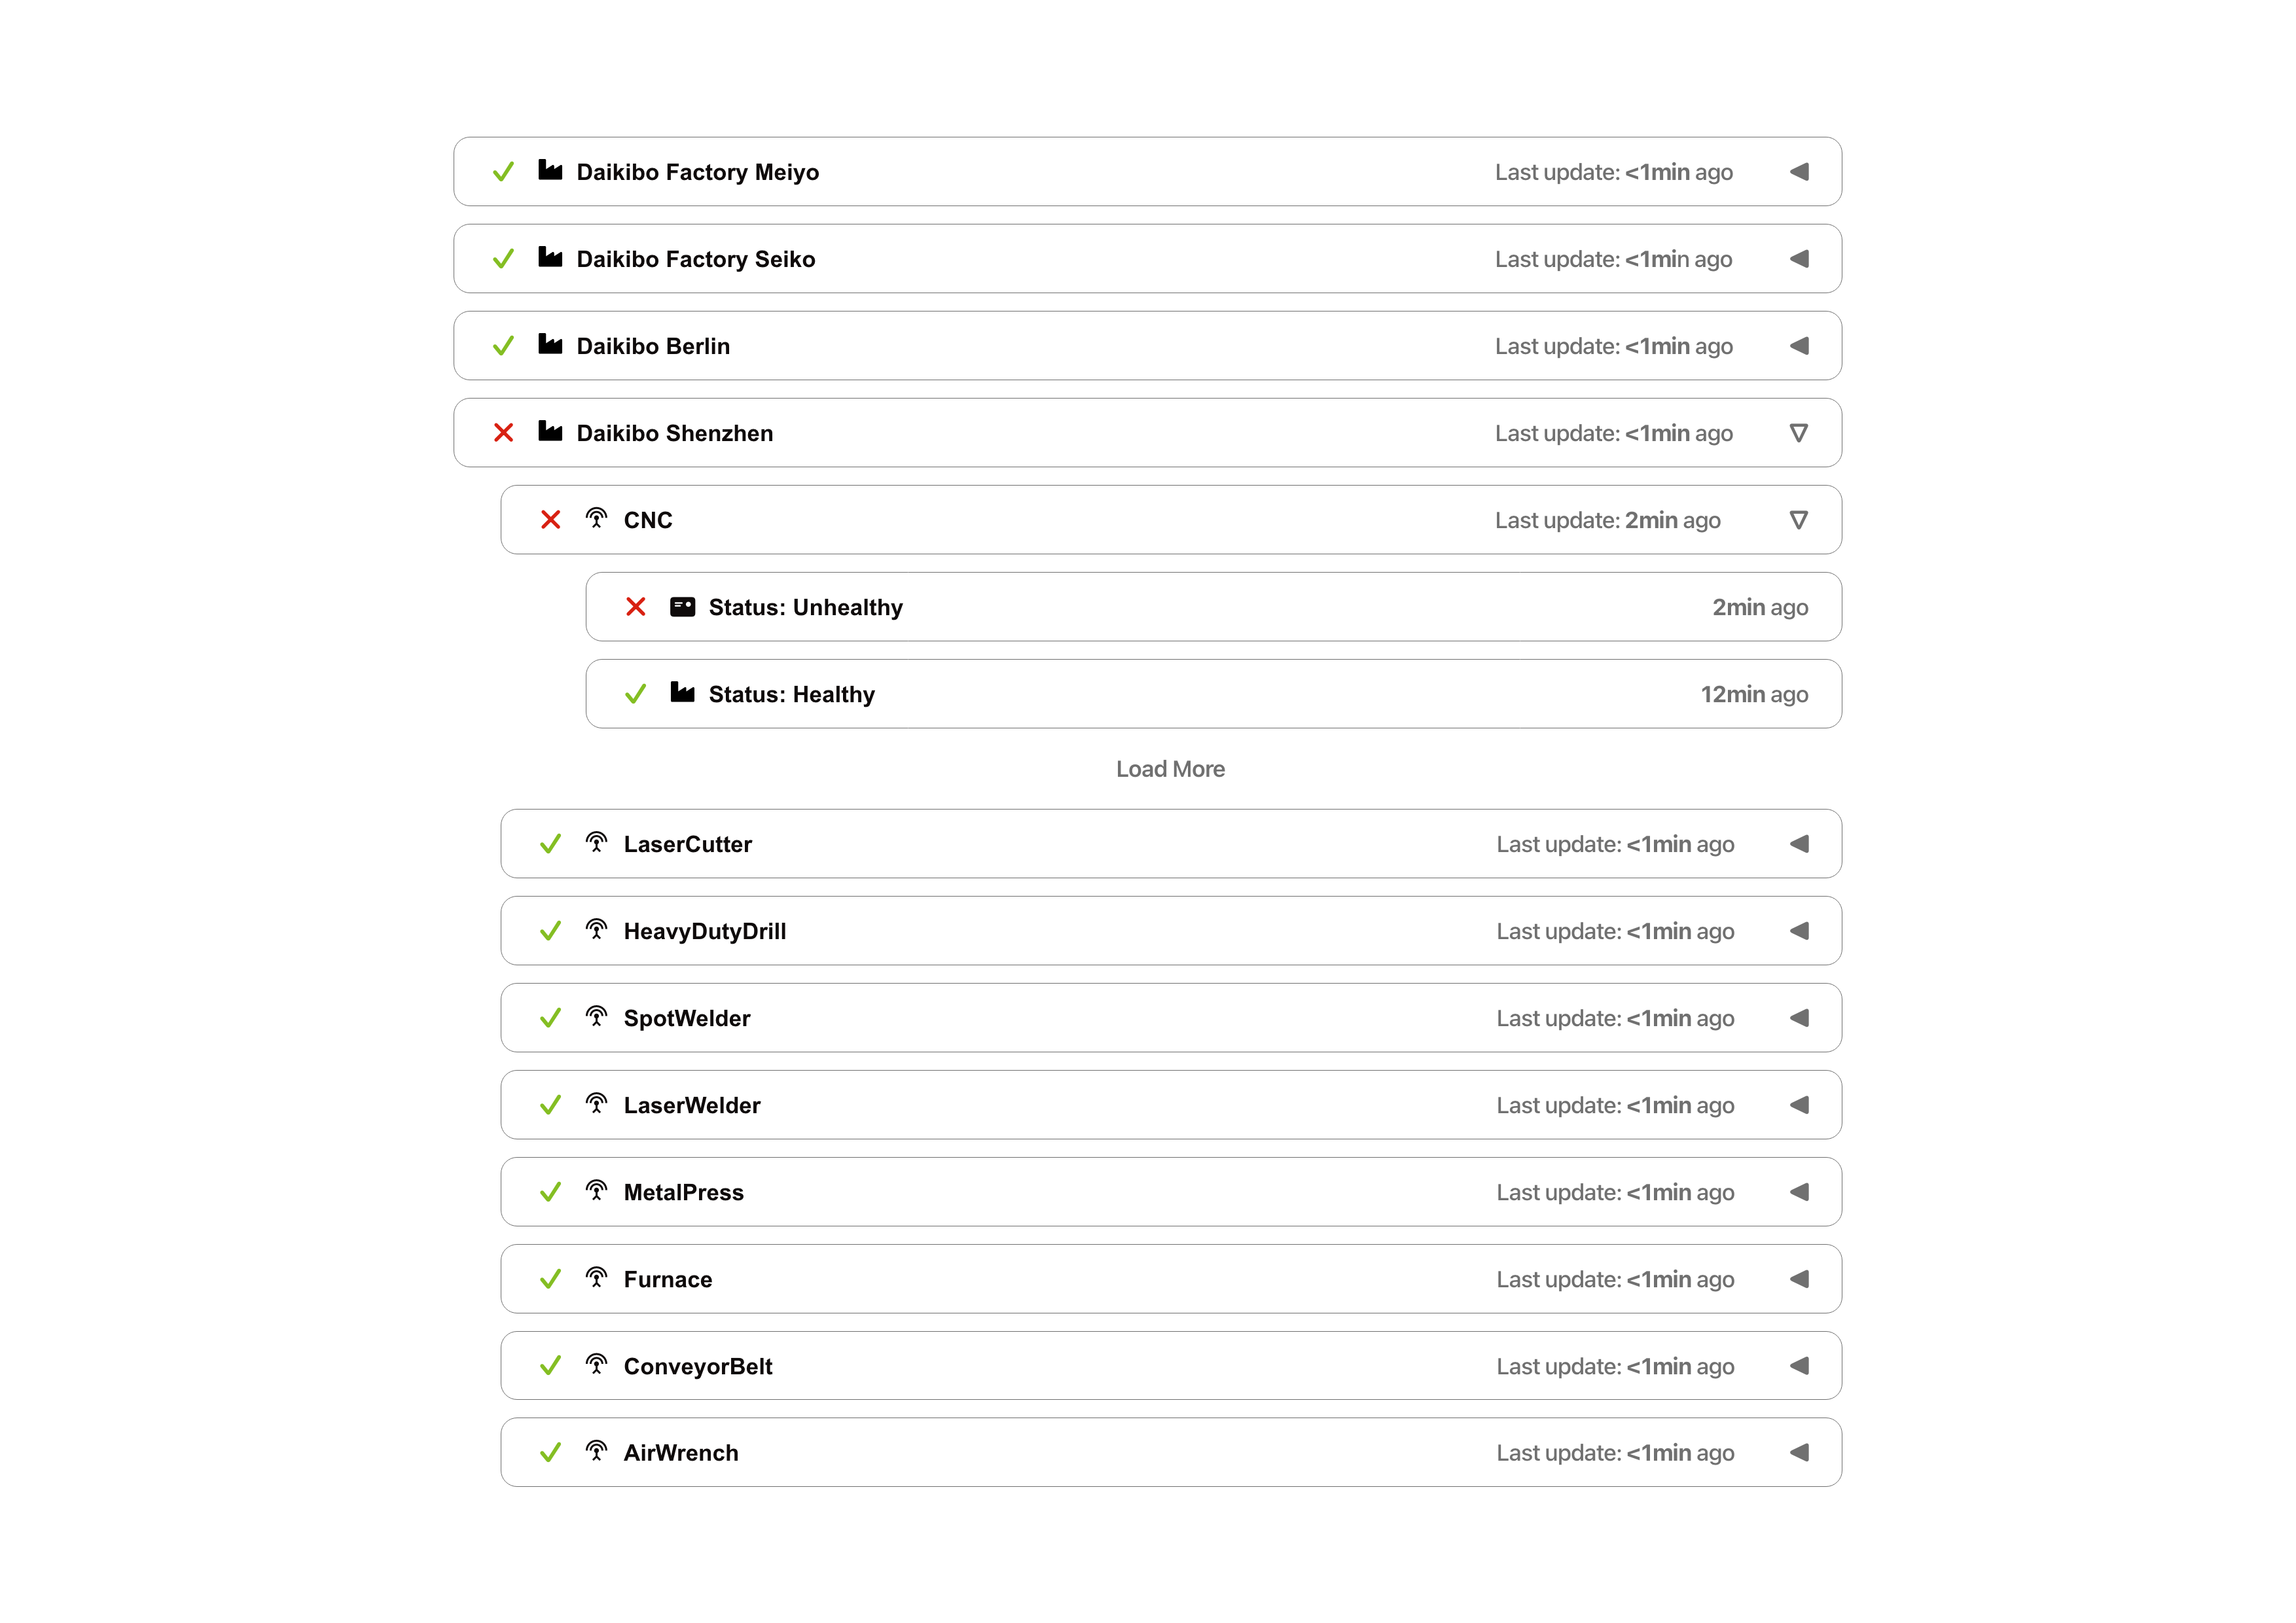
3. Estimate

The estimated effort required to complete the project is approximately 120 man-hours.
Development: 80 hours
- Dashboard user interface
- Authentication integration
- Real-time telemetry display
- Expandable factory and machine views
Testing: 25 hours
- Functional testing
- User acceptance testing
- Performance testing
- Bug fixing
Integration: 15 hours
- Deployment within Daikibo's intranet
- Authentication configuration
- Final system verification
Total Estimated Effort: 120 Man-Hours

4. Timeline

- 1 September 2024 – Project planning and design begins.
- 4 September 2024 – Requirements review and dashboard design completed.
- 9 September 2024 – Development of dashboard interface begins.
- 18 September 2024 – Implementation of authentication and telemetry integration completed.
- 23 September 2024 – Internal testing and bug fixing completed.
- 27 September 2024 – Integration into Daikibo's intranet environment.
- 30 September 2024 – Final review, client acceptance testing, and project delivery.

5. Support

Following project delivery, Deloitte will provide ongoing technical support to ensure the continued reliability and performance of the dashboard. Support services will include bug fixes, issue resolution through support tickets, performance monitoring, security updates, and maintenance activities.
In addition, Deloitte will assist with future enhancements and feature requests as Daikibo's operational requirements evolve. Regular updates and technical guidance will be provided to ensure the dashboard remains secure, reliable, and aligned with the client's business objectives.

